Stylish Earrings with your Janome Artistic Edge Digital Cutter
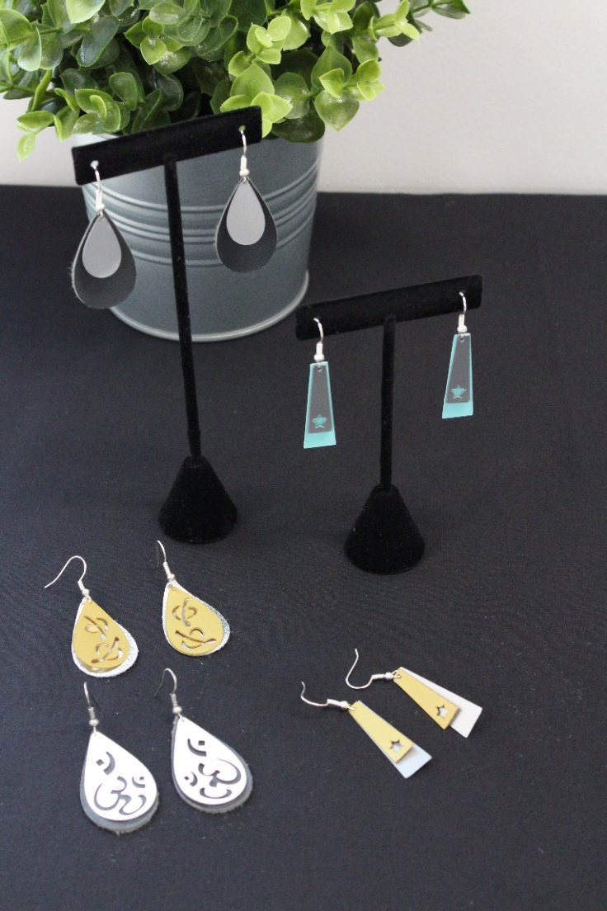
By Heidi Proffetty

Show off these stylish, lightweight DIY earrings made easy using inexpensive plastic party plates, leather scrap pieces and your Janome Artistic Edge Digital Cutter. Just cut, assemble and wear your own eye catching earrings in no time! After you complete this project, take what you’ve learned and have some fun creating a variety of different cut designs and color combinations to make additional sets of earrings.
Skill Level: Beginner/Intermediate
Design & Cutting Time: 1 hour

Supplies:
Plastic party plates less than 1mm thickness, assorted colors (large or smaller size, the plastic color should be the same on the front and back of plate)
5” x 5” pieces of Sheepskin or Faux leather material less than 1 mm thickness, assorted colors
1 - Package of Fishhook Ball Coil Earring Wires (found in the jewelry findings section of most craft stores)
Pair of fine tip pliers (jewelry pliers work perfect, used to open and close the chain links)
Fine tip tweezers
Painter’s Tape
Craft Scissors

Photo of Supplies:
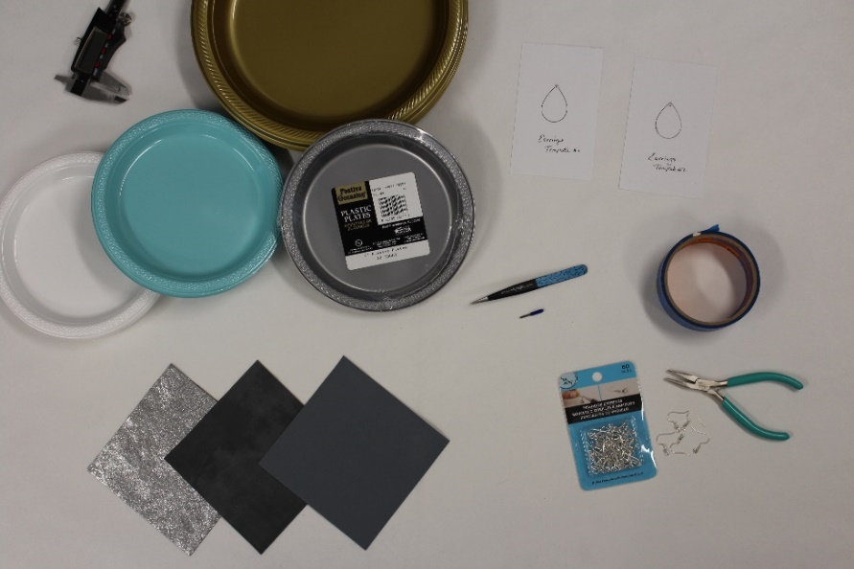
(Note: the earring templates shown in the above photo are sample designs only and are not used for this specific project)

Digital Cutter Equipment & Accessories Required:
Janome Artistic Edge Digital Cutting Machine
Simple Cuts Software (version 7.1 build 2017.8661)
High tack cutting mat
Blue cap blade (blade for cutting thicker materials such as stencil plastic & leather)

PART 1 - Creating Your Earring Design using Simple Cuts Software

This exercise will help you become more familiar with navigating the software, the various design features as well as how to create objects using the shapes tool.

- Open you Simple Cuts Software (select the Creative Drawings icon)
- Select Create new

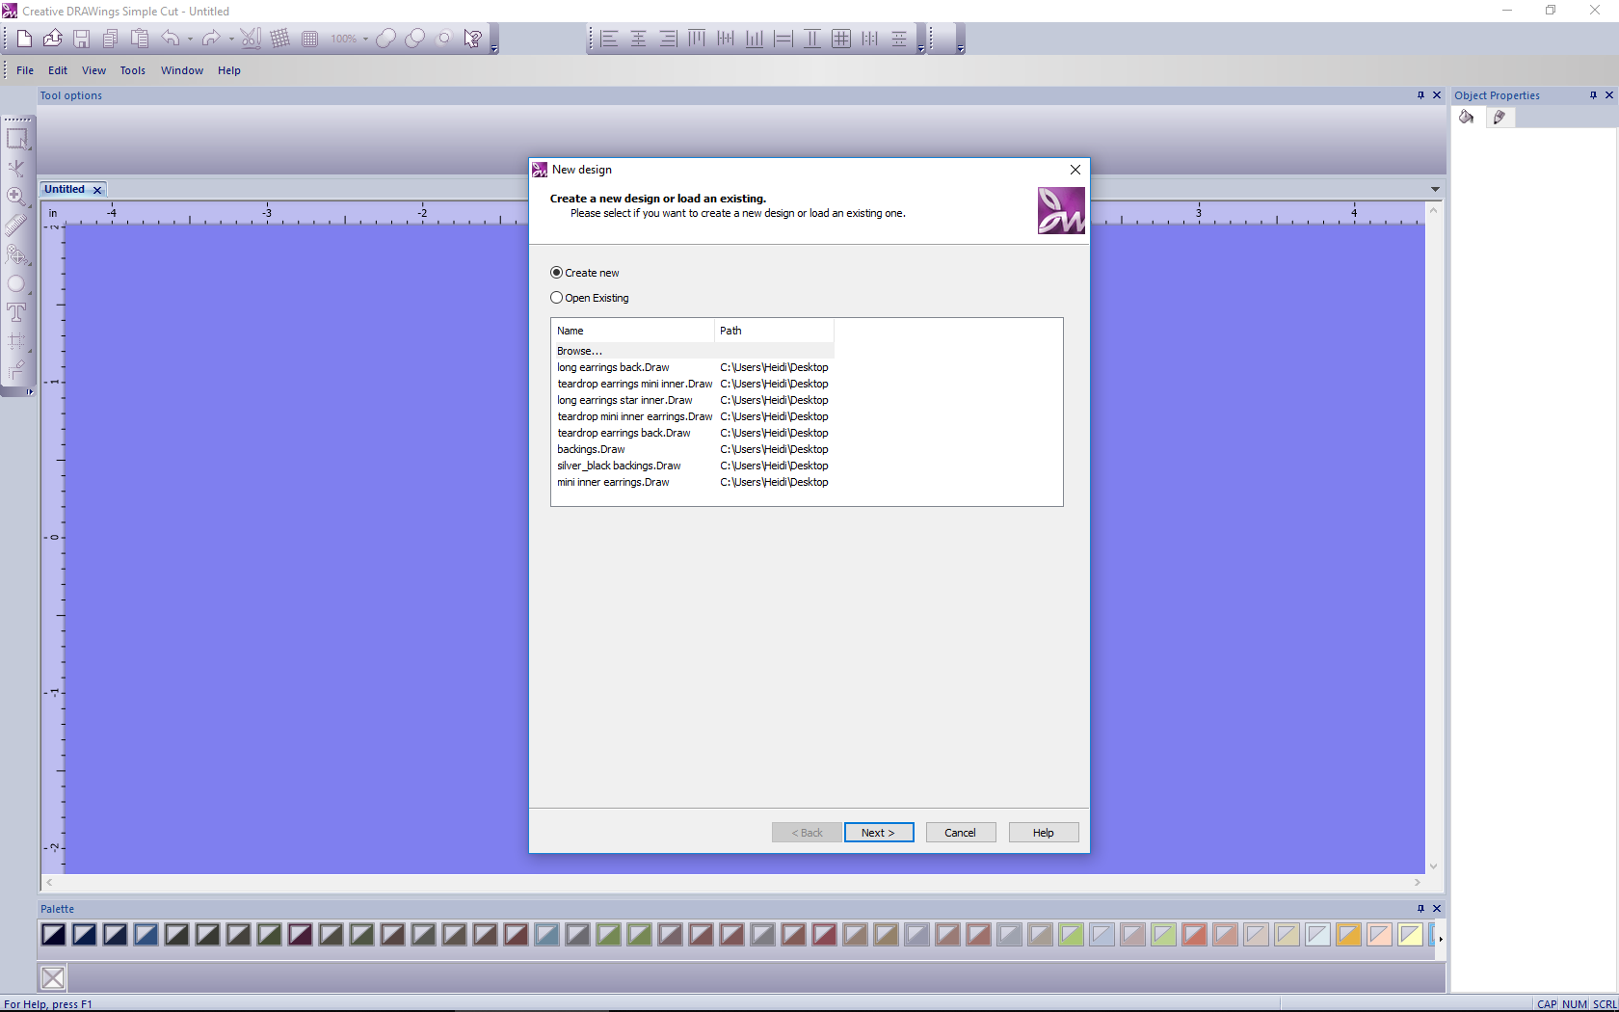

- Select Cut Technique (Green light turned on for cut technique, no lights should be tuned on for all other techniques)

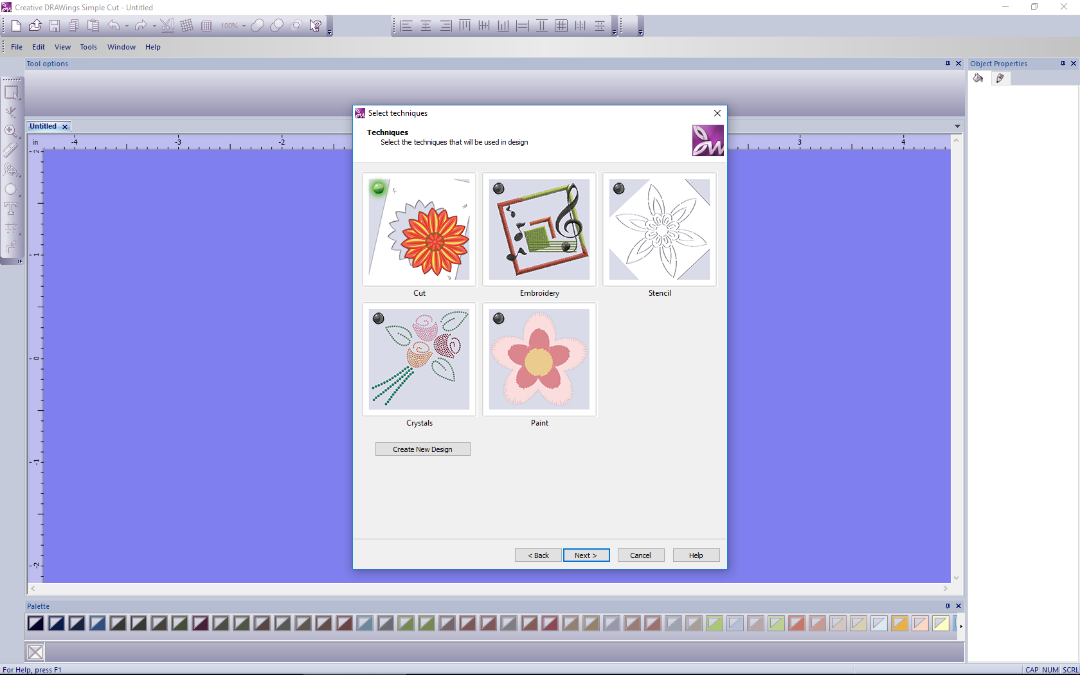

- Click Next button, Choose New Graphic, Click the Finish button (this opens a blank workspace)
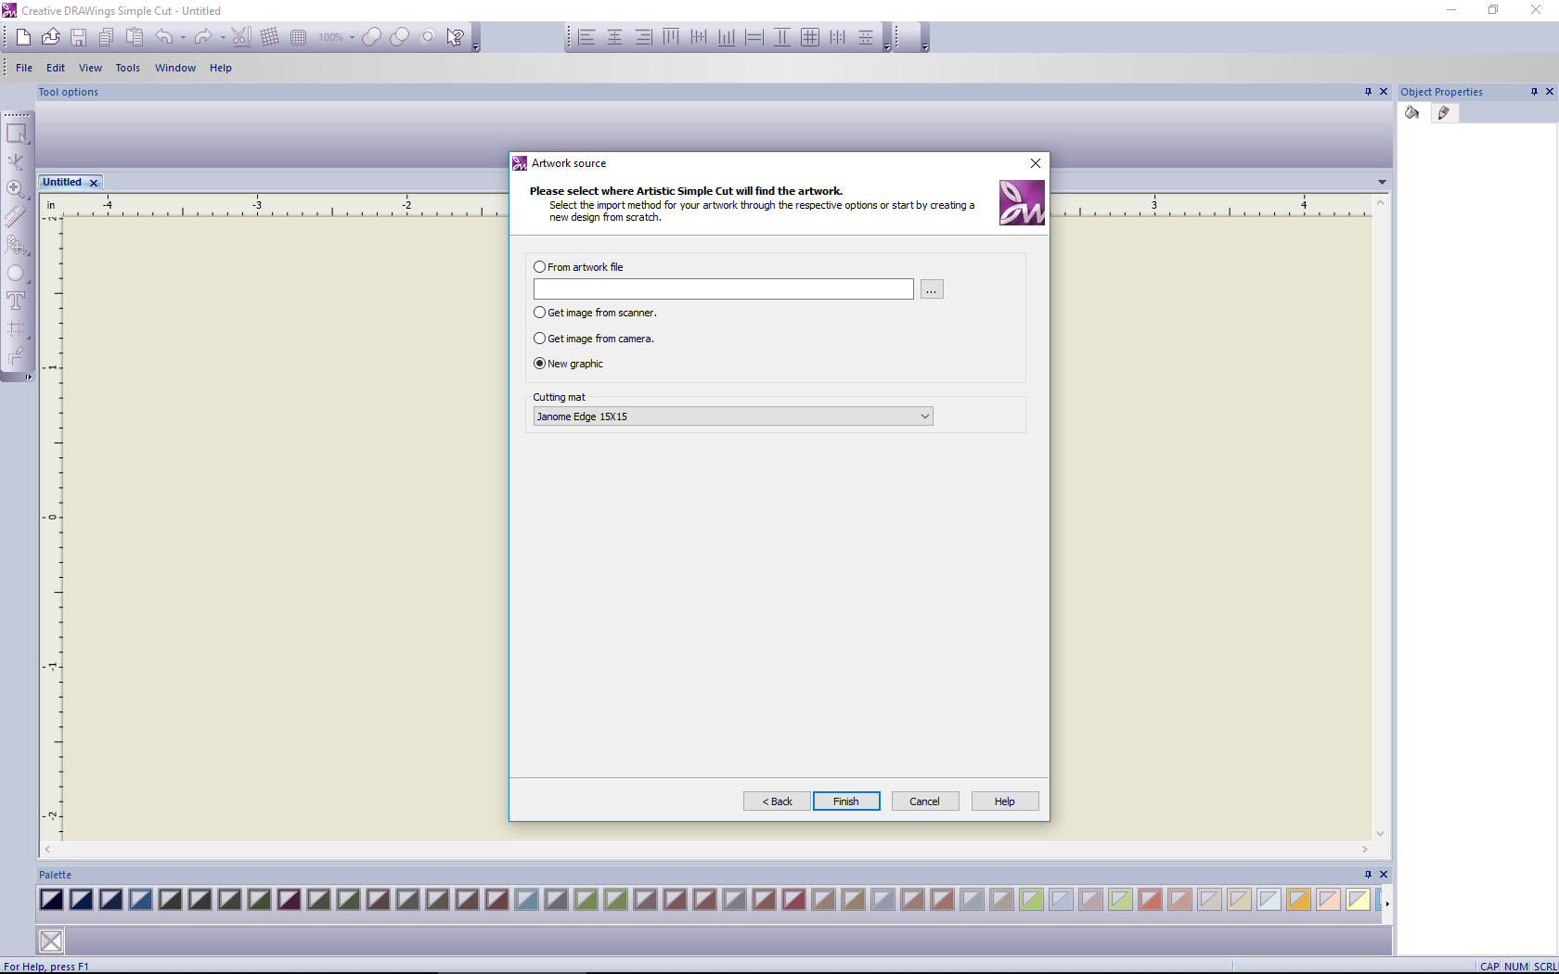
In this blank workspace, you can now start designing your earrings.

But before you start designing measure an existing earring to gauge the appropriate desired hanging length. For this project I have chosen 3.5 cm or approx.1.4 in.
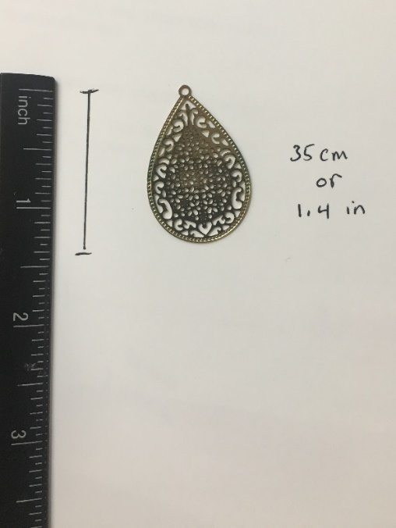
For this project we are going to create elongated trapezoid earrings with star cutout overlays.
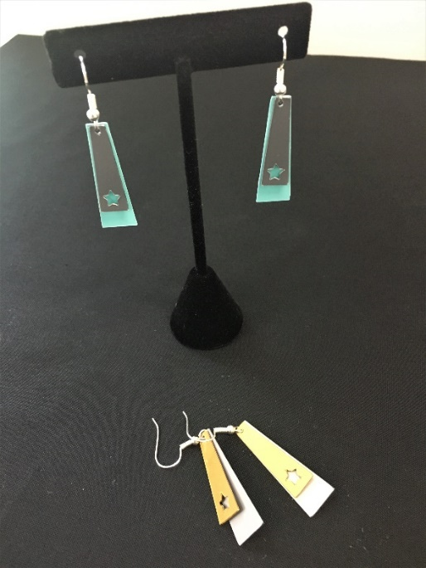
- Using the Tool bar on the left hand side of workspace, choose the Ellipse tool and click the little black arrow in the lower right corner. A fly out menu will open revealing all shapes available. Choose the Trapezoid shape.
Tip: When you hover over any of the tools, a small pop up box displays the name of the tool & description.
- Then in your workspace, using your mouse, right click and hold while drawing a trapezoid shape. Once you’ve drawn the trapezoid shape, using the Tool bar on the left hand side of workspace, choose the Rectangle selection tool. Click on your trapezoid shape, this will select that object and show you the current dimensions of your shape.
- You will need to now adjust the size. The software uses US measuring system. Choose 1.4” as length and .453” as width. To adjust size uncheck proportional in the tool option box at the top of your workspace, then manually enter .453 width and 1.4 length into width and height boxes. Your shape will adjust to these dimensions as you do this.
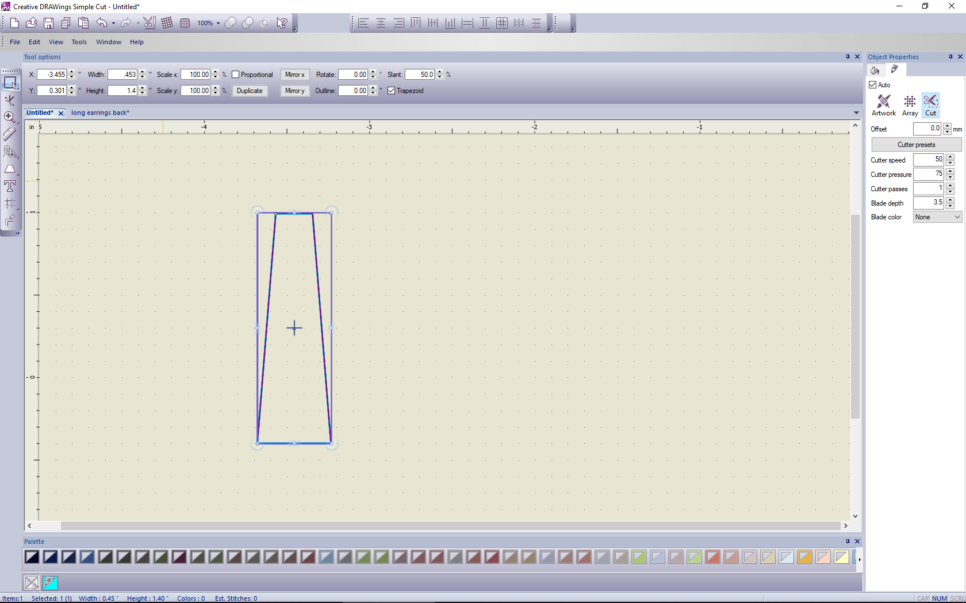
- Next, click on your Shapes tool again (left-hand tool bar) and this time chose an Ellipse (circle) shape. Position your curser inside the trapezoid and using your mouse, click + hold while you draw a small circle. Next resize the circle similar to how you resized the trapezoid. The dimensions I used for the circle were .097 width & .104 height.
- Now click on your Rectangle selection tool, click on your circle, then hover with your mouse over the outside border of the selected circle, 4 positioning arrows will appear allowing you to move your object. Using your mouse, move your circle shape so that it is centered and close to the top of the trapezoid shape.
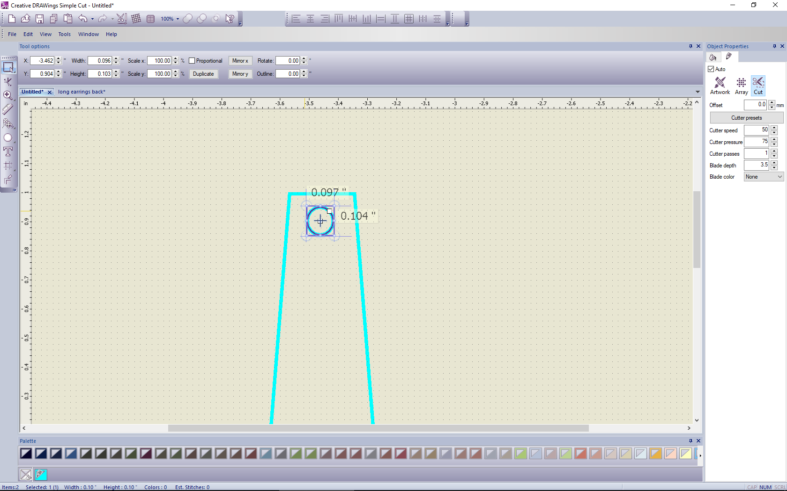
Congratulations! You just created one earring backing cut file but now this earring needs a companion.
- Next, click Edit on the standard tool bar at the top of workspace and choose Select All, this will select all of your objects at once or Click Control + A on your keyboard to do the same. Then right click, and choose copy, then choose paste. A duplicate of your shape will be created directly on top of your original shape with the exact same dimensions. Using your Rectangle select tool, click to select, hover with your mouse over the outside border until you see the 4 positioning arrows, then while clicking and holding your mouse, slide your copied shape to the right.
Congratulations! You have created your second earring backing.
- Go to File, Save As, Name your file (ex. Long earrings back). Save your file to a location you can easily find. You will access this file when it’s time to cut the shapes with your digital cutter.
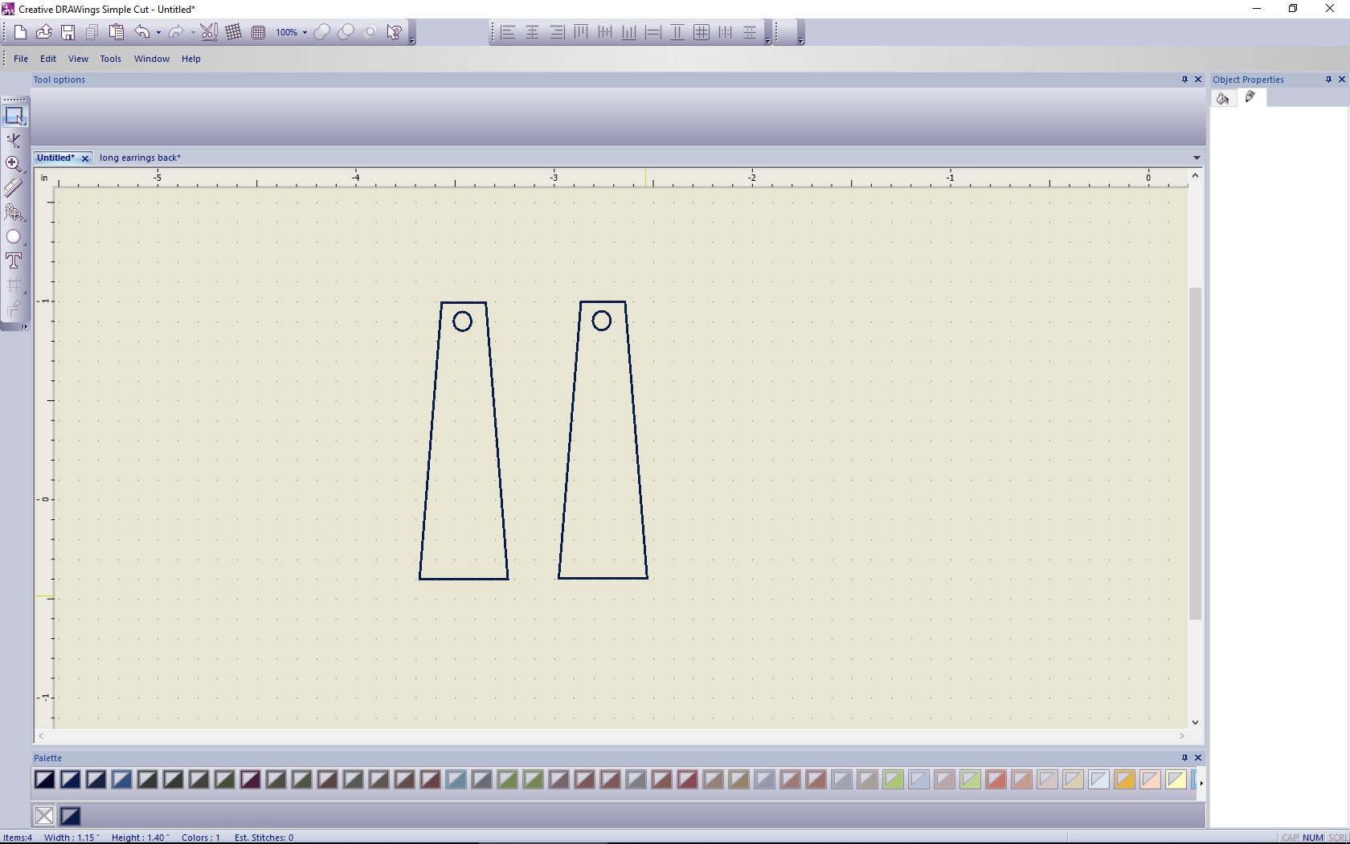
Now it’s time to create the top star layer for each of your earrings.
- With your saved long earring backing file still open, select your Shapes tool again from the left-hand menu and chose the star shape this time. At the top of the screen, under Tool Options you will see a selection for number of rays, choose 5 and then draw your star shape repeating the same steps as you did to draw the small circle. Place your star shape inside the lower part of each earring using copy and paste. To perfectly align the star shapes, holding your control key and using the rectangle selection tool, select both stars, with both stars selected, use your Center Align tool from the Align Tool Bar at the top of your workspace. Tip: You can always refer to your Y axis measurement in Tool Options to double check perfect alignment.

- Now that you have created your top star earring layer. Go to File, Save As, Name your file (Top star earring layer). Save your file to a location you can easily find. You will access this file when it’s time to cut the shapes with your digital cutter.
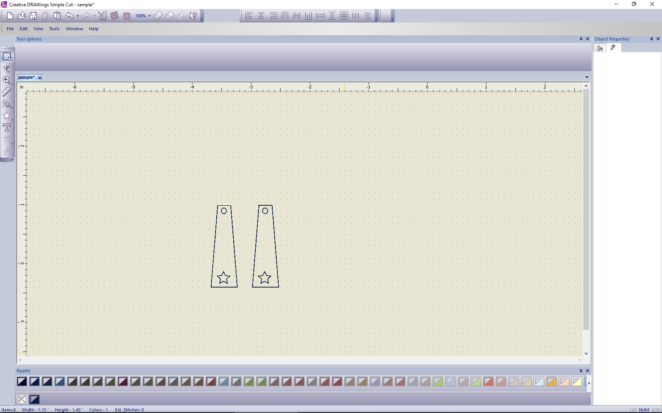

Congratulations! You have just finished creating a cut files for both earrings. It’s time to move on from the design phase to the cutting phase.
Preparing your materials for cutting

- Using a pair of craft scissors, cut the outside rim off of the plastic plate and discard. You should be left with flat plastic pieces which will be used to cut your earring designs from.

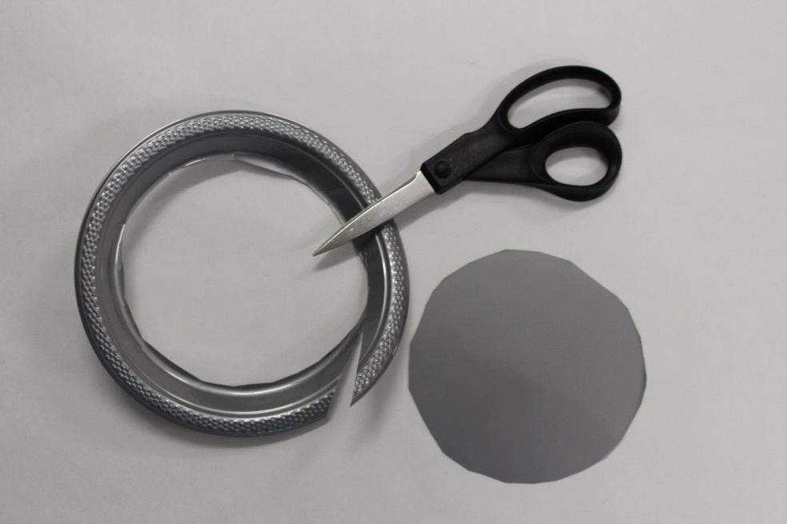
PART 2 – Cutting Your Earring Designs with Janome Artistic Edge
This exercise will help your become familiar with preparing and sending cut designs to your Edge Cutter.

Loading Material on Cutting Mat
- Using painters tape, tape the plastic plate center to your cutting mat securing it on all four sides of the plastic material. Then load your mat into the cutter.

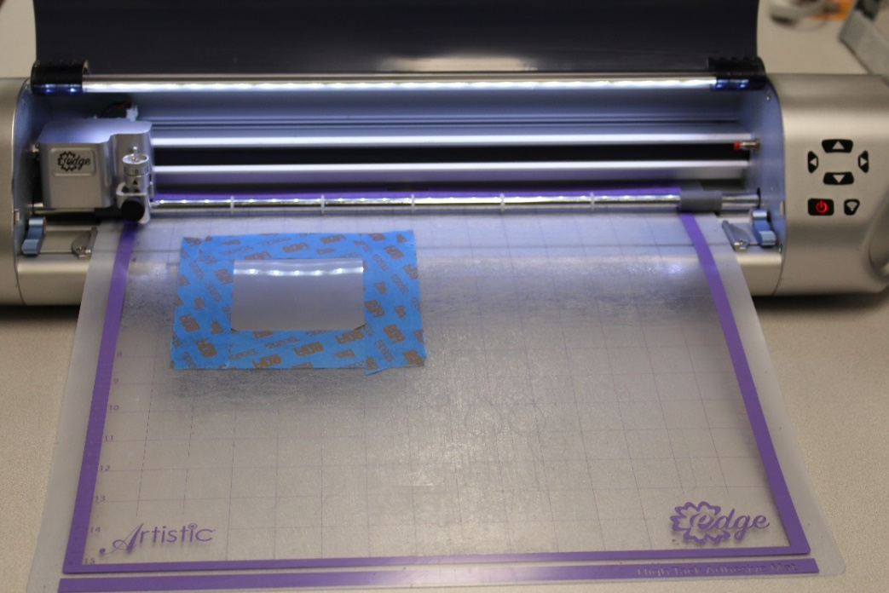

- Load the Blue blade into the blade holder. If you’re not sure how to do this refer to your user’s manual. Choose a Blade Depth of 10 (as recommended in the cutter presets dialog box). This dialog box appears each time you select an object.

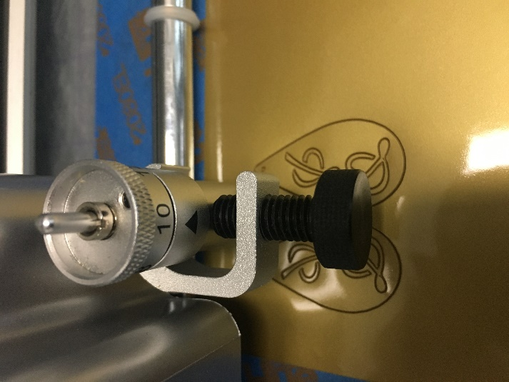
- Turn on your cutter by using the power button on the cutter unit.

Exporting the design to Edge Cutter
- Open you Simple Cuts Software (Creative Drawings Icon)
- Select Open Existing
- Then choose Browse and locate your earring design cut file (ex. long earrings back)

- Click on the Cutter Presets in the Objects Properties dialog box, on the right-hand side of your workspace, choose stencil plastic. Tip: Your design or object must be selected to see the Objects Properties dialog box.
- To send the design to the cutter select File at top, then from drop down menu select Export and To Cutters. Select your cutter (Artistic Edge USB) and hit the Connect button.
- Use the arrows in the Export to cutter dialog box to control the movement of the cutter head. The positioning is determined by the laser light. Use the arrows in the Export to cutter dialog box to jog the laser light into position.

In order to ensure the best cut results, before cutting your actual design perform a test cut and trace.

Perform a Test Cut
- Next move the laser to a position on the material that will not be used to perform a test cut. Check your cut results and make changes to cutter pressure or blade depth (the blade depth is adjusted manually by rotating the dial on the blade holder.
Tip: Keep a chart to log: material type, cut pressure, speed, blade depth, type of blade and number of passes) it will come in handy for future reference.
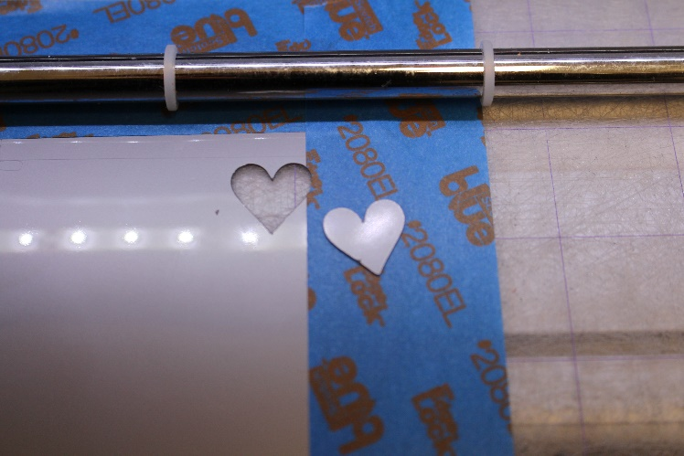
- Once you have achieved desired test cut results, move the laser light to the upper most top left corner of your material.
Tip: Remember you are aligning the laser light (not the blade) to the desired cut location.
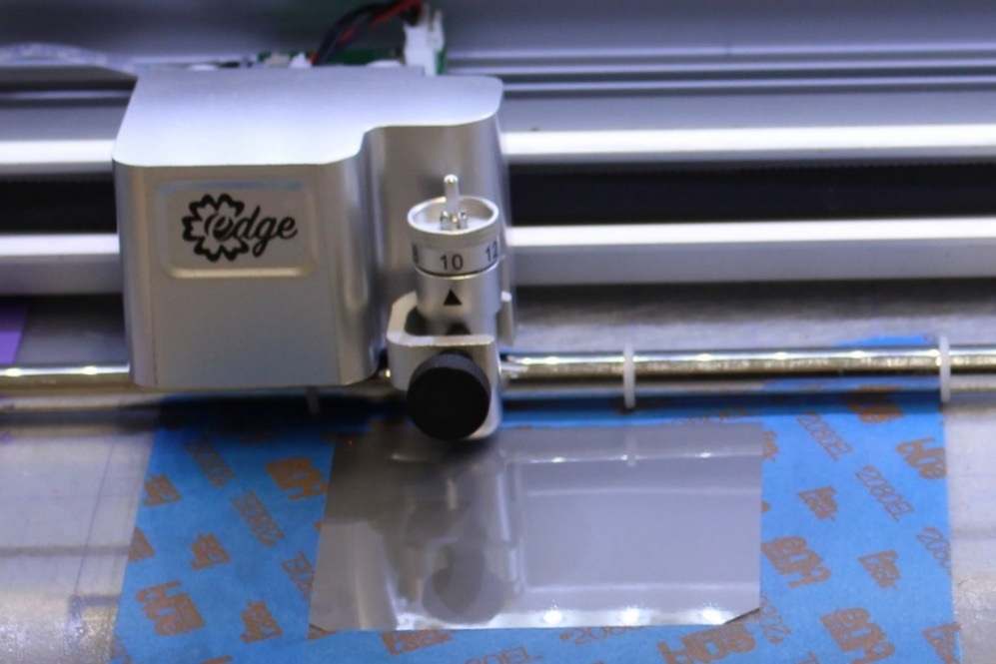
Perform a Trace
- To perform a Trace select the Trace button and follow the laser to preview the cutting location. This will ensure that your cut will occur exactly where you want on the material. Using Trace feature, the cutter will trace the required dimensions of the object but will not actually cut the material.
- Use the arrow keys to do any repositioning if necessary.
Using the Sequence Manager (Trays) to determine the Order to Cut Objects
You would use the sequence tray feature to cut by specific order, first the inner objects of your earrings (the circle and stars) then the outer earrings. This prevents shifting of the plastic and improves your cut results.
- Make sure Sequence Manager is turned on. Go to View in you Standard Tool bar at the top and view the dropdown, there should be a check mark next to Sequence Manger, if not, click on it to turn it on.
- Left click to select each object, then right click, a menu will appear, choose break apart to separate objects. Note: if break apart doesn’t appear, it may mean that your object are already separated.
- You should see your Sequence trays visible in your workspace. Simply reorder the trays by clicking on one and sliding it into numeric order. The objects that are inside the earrings (ex. the circles and stars) should be cut first, next the outer earrings. Note: if you don’t see all the trays, use the scroll bar to the right of the Sequence Manger to reveal additional trays.
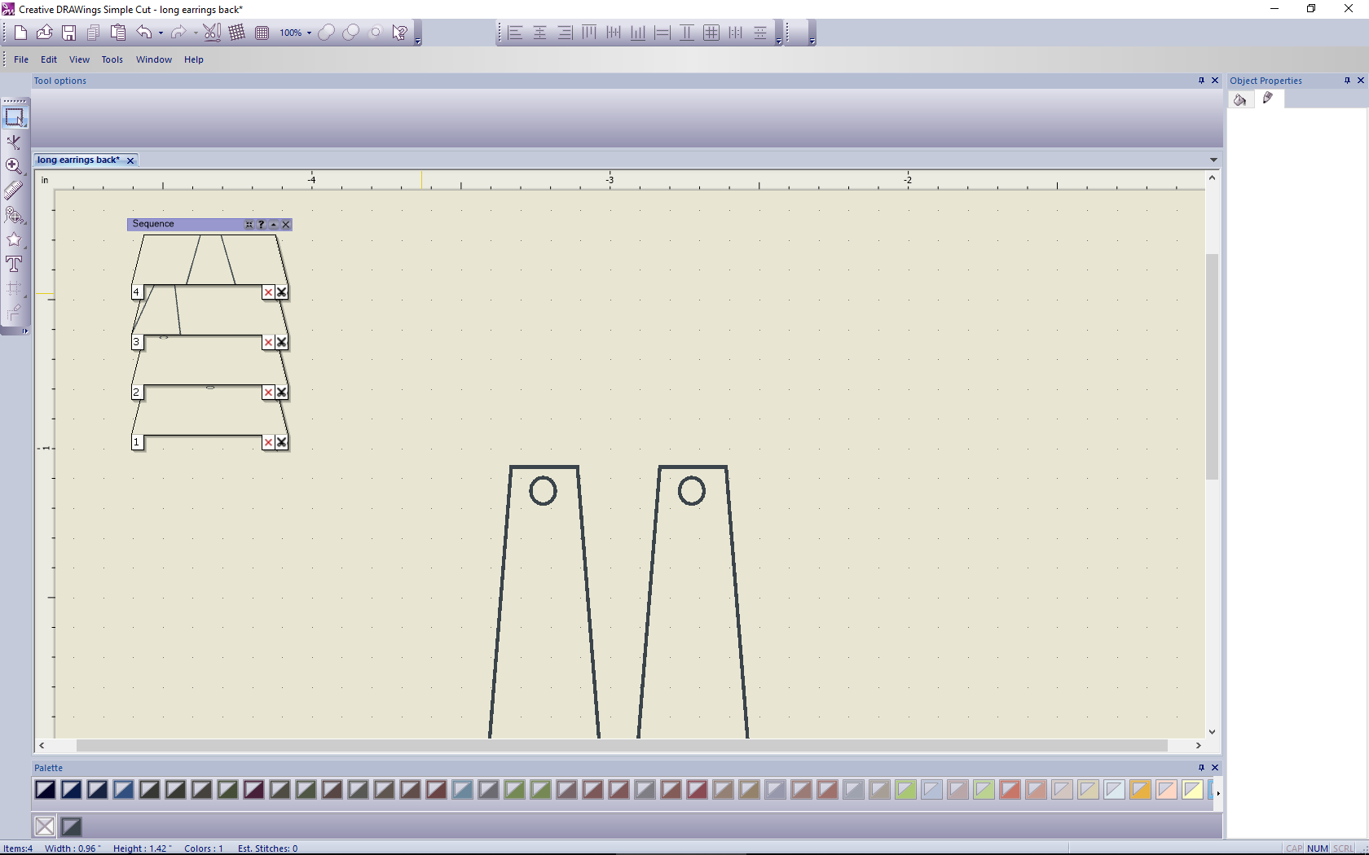
Now you’re ready to cut your design!

Cutting the Design
- Follow the Export to Cutter steps above, except this time no Test cut is needed.
- Select the Cut button and the cutter will cut your design in seconds!
- Once the design is finished cutting, close the Send Completed dialog box by selecting OK.
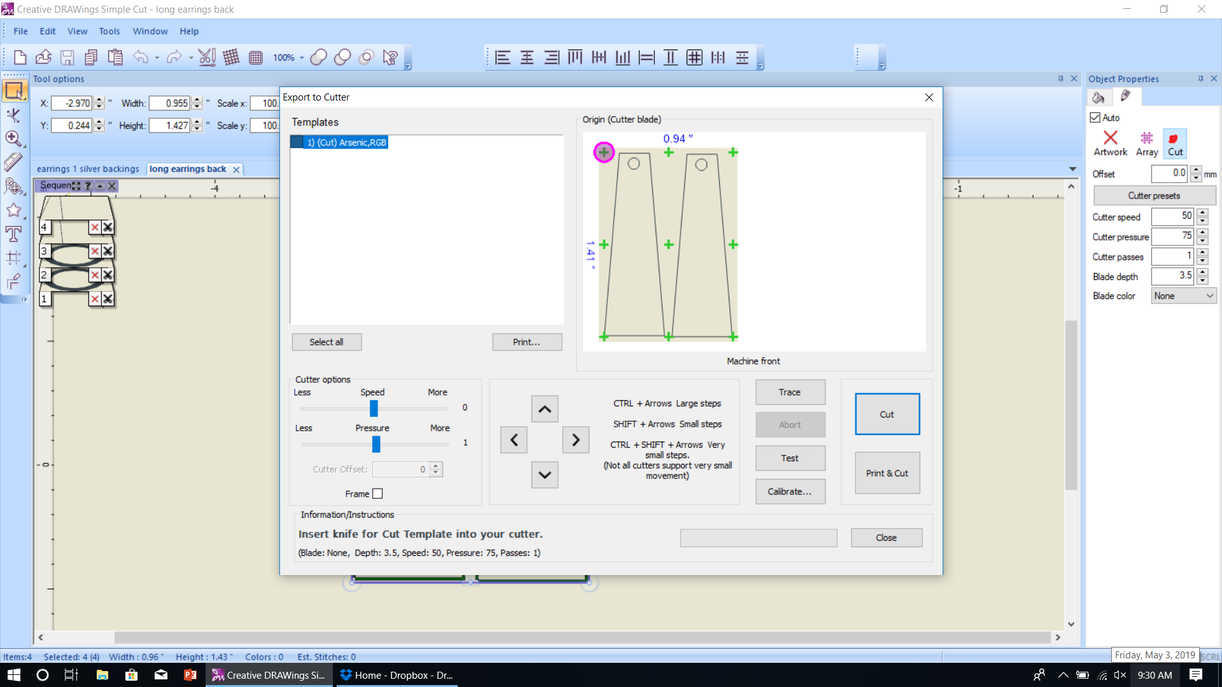
Removing your cut design from the cutting mat
- First carefully remove the painters tape.
- Then using a pair of ultra-fine, precision tipped tweezer’s carefully lift the plastic from the cutting mat and set aside, your earrings should be left behind on the cutting mat.
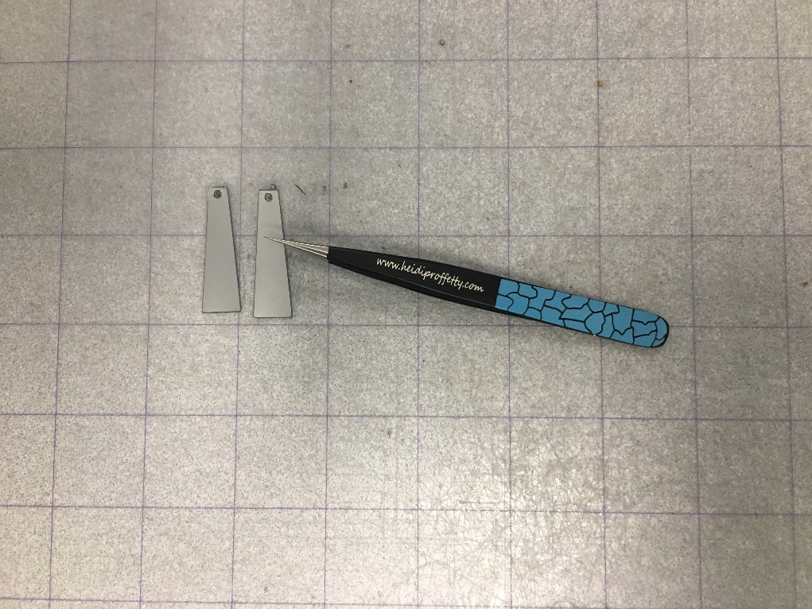
Figure 1: Heidi's Proffetty's Precision Tweezers available at www.heidiproffetty.com/shop

- Then carefully lift your earring shapes from the cutting mat. Use your tweezers to gently poke out any of the smaller circles and/or star shapes etc.
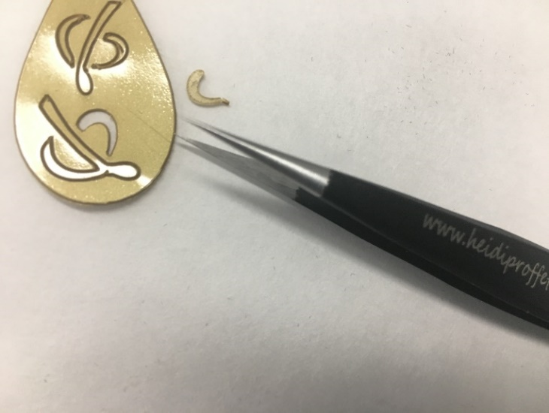
Cutting Your Second Earring Design
- This time using a different colored piece of plastic, repeat the same cutting procedures above and cut your second design (ex. top star earring layer). Once you are finished cutting, use your tweezers to gently poke out any of the smaller circles and/or star shapes.
Assembling the Earrings
- Using your fine tipped pliers, open the chain link and attach one earring backing and on top of the backing layer, one star earring layer.
- Then using pliers close the loop.
- Repeat this step for both earrings.
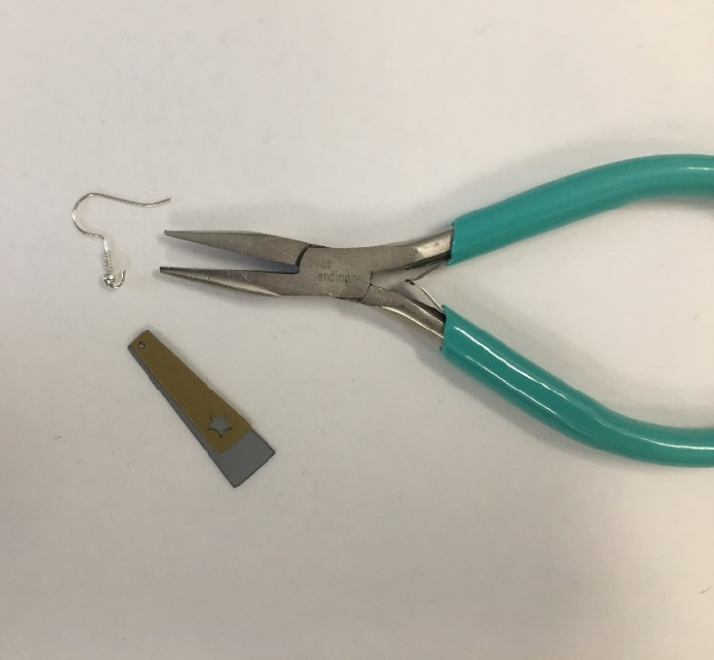
You can use this same process to create many different types of designs as seen in the first photo. For example you can use Symbols/Wingdings as an option to create decorative cut inserts. (Select Tools, drop down and select Insert Symbol) Or you can draw your own earring design, import it and trace it using the Simple Cuts software. The options are truly endless!

